

Helwan University
Faculty of Engineering
Computer and System Department

Telnet Brute Force Attack
Network Security Project Report

Supervised by: Eng.Abdelrhman Yasser
Semester: Mainstream 2025

Team Members:
Salma Ahmed Eltayb
Boles Medhat Arian
Habeba Mostafa Desoky

Submission Date: 19 December 2025

Table of Contents
1. Introduction 3
2. Lab setup & topology 3
2.1 Lab Environment 3
2.2 Network Topology 4
3. Attack execution 4
3.4 Traffic Labeling Strategy 7
4. Dataset 8
Data Cleaning: 8
Data Preprocessing 8
5. Feature descriptions 8
6. Feature selection 9
7. ML models 9
8. Evaluation and comparison 10
9.Deployment 11
Deployment Overview 11
9.1 Deployment Environment 11
9.2 Deployment Architecture 12
10. CONCLUSION & FUTURE WORK 14
Conclusion 14
Future Work 14

1. Introduction
Telnet is a legacy remote login protocol that transmits credentials in plaintext over the network. Due to its lack of encryption and weak authentication mechanisms, Telnet services are highly vulnerable to brute-force attacks. In a Telnet brute-force attack, an attacker repeatedly attempts to authenticate to a Telnet service using different usernames and password combinations until valid credentials are discovered.
In this project, a Telnet brute-force attack was simulated using the Metasploit Framework’s auxiliary/scanner/telnet/telnet_login module. The objective of the attack was to generate realistic malicious traffic that can be distinguished from normal network behavior using machine learning techniques. The resulting dataset was used to build and evaluate an intrusion detection system (IDS).

2. Lab setup & topology

2.1 Lab Environment
The experimental setup was implemented using virtual machines to simulate a real-world network attack and detection scenario.
Machines Used
Machine | OS
Attacker | Kali Linux
Victim Machine (Dataset Collection) | Metasploitable 2
Deployment | Ubuntu
All machines were connected using Nat Network to ensure isolation and safety.
Tools & Technologies
- Wireshark / TShark / PyShark – packet capturing
- Python – ML inference
- Scikit-learn – ML models
- Joblib – model persistence
- VirtualBox / VMware – virtualization

2.2 Network Topology

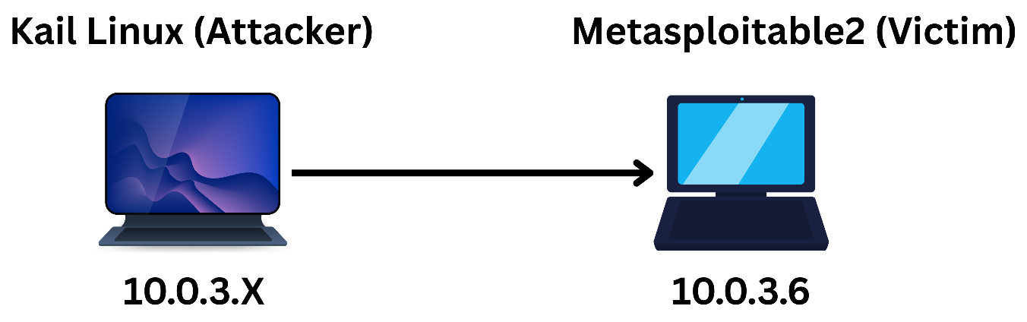
Figure 1: Network Topology
Traffic between the two machines was captured on the Kali Linux machine using tshark. Separate captures were performed for normal (benign) traffic and attack traffic to allow proper labeling of the dataset.

3. Attack execution
3.1 Network Discovery and Service Identification
Before launching the attack, network reconnaissance was performed to identify active hosts and confirm that the Telnet service was running on the target machine.
Host discovery and port scanning:
The following Nmap command was used to scan the target machine:
nmap -sS -p 23 10.0.3.6
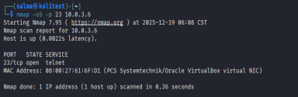
The scan results confirmed that port 23 (Telnet) was open and accessible on the target system, indicating that the Telnet service was running and vulnerable to brute-force attacks.

3.2 Normal Traffic Generation (Label = 0)
After confirming network connectivity, normal (benign) traffic was generated to simulate legitimate user behavior. Standard client tools were used with controlled timing to avoid aggressive or attack-like behavior.
commands used:
telnet 10.0.3.6
ftp 10.0.3.6
wget http://10.0.3.6
while true; do
curl http://10.0.3.6
wget -q -O /dev/null http://10.0.3.6
sleep 3
done
These commands were executed repeatedly with delays to generate steady and realistic TCP traffic.
Traffic capture command:
sudo tshark -i eth0 -f "host 10.0.3.6" -w normal_telnet.pcapng
Feature Extraction from Captured Traffic
After completing the traffic capture, the recorded PCAP file was converted into a structured CSV dataset suitable for machine learning analysis. This was achieved using the following tshark command:
tshark -r normal_telnet.pcapng \
-Y "tcp" \
-T fields \
-E header=y \
-E separator=, \
-E quote=d \
-E occurrence=f \
-e frame.time_epoch \
-e frame.time_delta \
-e frame.time_relative \
-e frame.len \
-e ip.proto \
-e tcp.srcport \
-e tcp.dstport \
-e tcp.flags \
-e tcp.len \
-e tcp.stream \
-e tcp.window_size \
> normal_features.csv
All packets extracted from this capture were labeled as normal traffic (label = 0) in the dataset.
3.3 Telnet Brute-Force Attack Execution (Label = 1)
Once the Telnet service was confirmed to be open, a brute-force attack was launched using the Metasploit Framework. A Metasploit resource script (telnet.rc) was used to automate the attack.
Traffic capture during the attack:
sudo tshark -i eth0 -f "host 10.0.3.6" -w attack_telnet.pcapng
Command used to perform attack:
msfconsole -r telnet.rc
Feature Extraction from Captured Traffic
After completing the traffic capture, the recorded PCAP file was converted into a structured CSV dataset suitable for machine learning analysis. This was achieved using the following tshark command:
tshark -r attack_telnet.pcapng \
-Y "tcp" \
-T fields \
-E header=y \
-E separator=, \
-E quote=d \
-E occurrence=f \
-e frame.time_epoch \
-e frame.time_delta \
-e frame.time_relative \
-e frame.len \
-e ip.proto \
-e tcp.srcport \
-e tcp.dstport \
-e tcp.flags \
-e tcp.len \
-e tcp.stream \
-e tcp.window_size \
> attack_features.csv
All packets captured during this phase were labeled as attack traffic (label = 1).

3.4 Traffic Labeling Strategy
Traffic labeling was performed based on the context of traffic capture. Separate CSV files were created for normal and attack traffic, and a label column was added to each dataset.
Packets captured during normal user activity were labeled as 0 (normal):
awk 'NR==1{print $0",label"} NR>1{print $0",0"}' normal_features.csv \ > normal_labeled.csv
Packets captured during the Telnet brute-force attack were labeled as 1 (attack):
awk 'NR==1{print $0",label"} NR>1{print $0",1"}' attack_features.csv \ > attack_labeled.csv
After labeling, both datasets were merged into a single file using the following command:
cat normal_labeled.csv attack_labeled.csv > final_dataset.csv
This command concatenates the two labeled CSV files into a single dataset. Since both CSV files were generated using the same feature extraction process and contain identical column structures, they can be safely combined for machine learning analysis.

4. Dataset
- Packet-level features were extracted from both PCAP files using tshark.
- Final dataset statistics:
Class | Records
Normal | 3125
Attack | 2599
Total | 5724

Data Cleaning:
- Missing values were checked
- Duplicate rows were checked
- Non-numeric or Hexa features were encoded
- Time-related features were removed to avoid data leakage

Data Preprocessing
- Dataset split:
90% Training , 10% Testing , Stratified split to preserve class distribution
- Feature scaling applied using StandardScaler.
- Class imbalance handled using class_weight='balanced'.

5. Feature descriptions
Feature | Description
frame.time_epoch | Absolute timestamp of the packet
frame.time_delta | Time difference between consecutive packets
frame.time_relative | Time since the beginning of the capture
frame.len | Total packet length in bytes
ip.proto | IP protocol number (TCP = 6)
tcp.srcport | Source TCP port
tcp.dstport | Destination TCP port (23 for Telnet)
tcp.flags | TCP control flags indicating connection state
tcp.len | Length of TCP payload
tcp.stream | Identifier for individual TCP connections

TCP Flags Encoding
The tcp.flags field was converted into binary features:
- tcp_FIN
- tcp_SYN
- tcp_RST
- tcp_PSH
- tcp_ACK
- tcp_URG

6. Feature selection
Recursive Feature Elimination (RFE) with a Random Forest estimator was used to select the most important features.
Selected Top Features:
- frame.len
- tcp.len
- tcp.stream
- tcp.window_size
- tcp_PSH
This step reduces dimensionality and improves model generalization.

7. ML models
The following models were trained and evaluated:
- Random Forest: Ensemble-based model suitable for handling non-linear patterns.
- Decision Tree: Interpretable model for rule-based classification.
- XGBoost: Gradient boosting model optimized for performance.
- LightGBM (Light Gradient Boosting Machine) is an open-source, high-performance gradient boosting framework developed by Microsoft.
- CatBoost is an ensemble learning algorithm based on gradient boosting that builds multiple decision trees sequentially to improve prediction accuracy.

8. Evaluation and comparison
Model | Accuracy | Precision | Recall | F1-Score | Balanced Accuracy
Random Forest | 0.8917 | 0.8848 | 0.9216 | 0.9028 | 0.8887
Decision Tree | 0.8865 | 0.8814 | 0.9152 | 0.8980 | 0.8836
XGBoost | 0.8672 | 0.8655 | 0.8960 | 0.8805 | 0.8643
CatBoost | 0.9004 | 0.8925 | 0.9296 | 0.9107 | 0.8975

Results:
- CatBoost achieved the best overall performance across all evaluation metrics, with the highest Accuracy (90.04%), F1-score (91.07%), and Balanced Accuracy (89.75%).
This indicates strong generalization and balanced detection of both attack and normal traffic.
- Recall is the most critical metric for Intrusion Detection Systems.
CatBoost also recorded the highest Recall (92.96%), making it the most reliable model for detecting Telnet attacks with minimal false negatives.
- Random Forest showed competitive performance with high recall (92.16%) and stable balanced accuracy, confirming its robustness for network traffic classification.
- Decision Tree performed well with slightly lower metrics than Random Forest, while maintaining good interpretability—useful for understanding decision rules.
- XGBoost, although effective, underperformed compared to other ensemble models, particularly in balanced accuracy, indicating slightly weaker handling of class imbalance.

9.Deployment

Deployment Overview
After training and evaluating the Machine Learning models offline, the intrusion detection system was deployed locally on a victim-side machine to perform real-time traffic classification. The deployment environment was designed to simulate a realistic scenario where the detection logic runs directly on the monitored host without relying on external servers.
The deployment was implemented on an Ubuntu virtual machine, which represents the victim machine in the live environment. This machine supports Python execution and packet inspection libraries, making it suitable for lightweight IDS deployment.

9.1 Deployment Environment
- Operating System: Ubuntu Linux
- Programming Language: Python
- Packet Capture Tool: PyShark (Python wrapper for TShark)
- Trained Model: Random Forest (saved after training)
The attacker machine (Kali Linux) generates Telnet traffic, while the deployed IDS on Ubuntu listens to the network interface and classifies packets in real time.

9.2 Deployment Architecture
- Kali Linux initiates Telnet attacks.
- Ubuntu machine captures live traffic using PyShark.
- Extracted features are passed to the trained ML model.
- Traffic is classified as Normal or Attack in real time.

Open port tcp 23 and make environment for all libraries

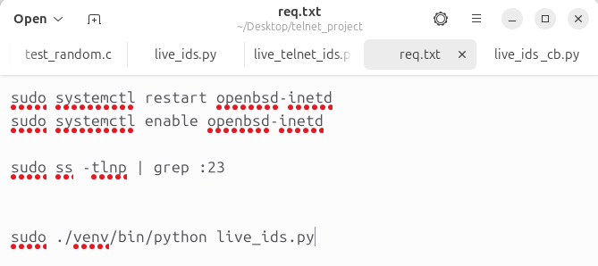
Try make flood of Attack
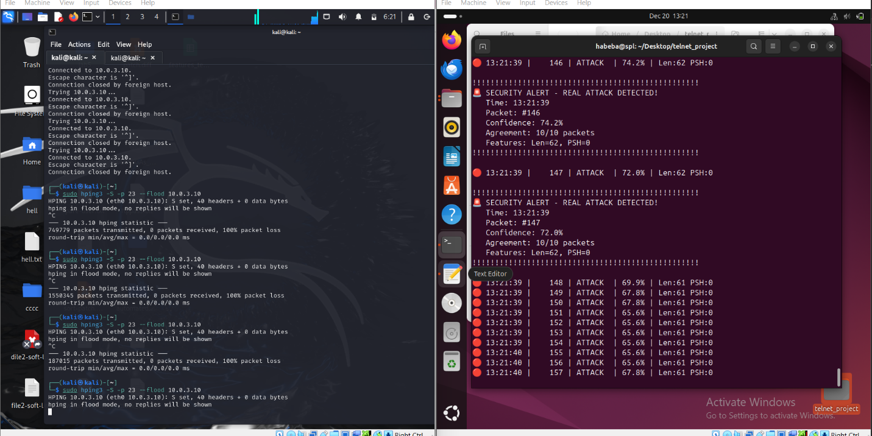

Using Msfconsole
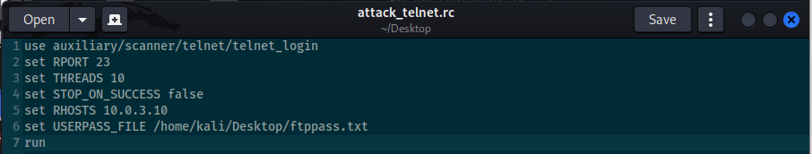

Real Time Snapshot
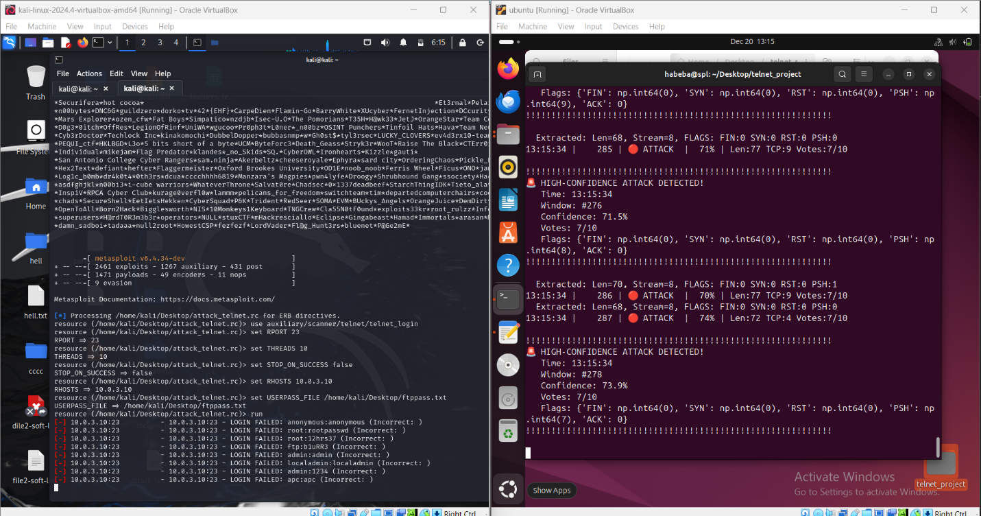

10. CONCLUSION & FUTURE WORK

Conclusion
This project demonstrated the effectiveness of Machine Learning techniques in detecting Telnet-based attacks using network traffic features. The trained models successfully distinguished between normal and malicious traffic with high accuracy, validating the feasibility of lightweight IDS deployment.
The deployment on an Ubuntu machine using PyShark showed that trained models can be integrated into real-time monitoring environments.

Future Work
- Extend detection to other attack types and protocols (SSH, FTP).
- Implement deep learning-based models for temporal analysis.
- Deploy the system as a real-time IDS service.
- Integrate automated alerting mechanisms.

